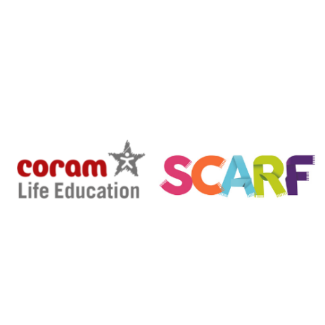

ORDER FORM
Coram Life Education cle@coram.org.uk
Coram Campus 020 7520 0364
41 Brunswick Square
London
WC1N 1AZ

To: SCHOOL NAME
STREET ADDRESS DATE: DD/MM/YYYY
POST CODE
PHONE
EMAIL
TICK All That apply APPLICABLE | ITEM | DESCRIPTION – SCARF |  | ITEM PRICE | VAT | TOTAL
 | SCARF ONLINE EXTRA LARGE | EXTRA LARGE (401+ pupils) |  | £770 | £154 | £924
 | SCARF ONLINE LARGE | LARGE (301-400 pupils) |  | £650 | £130 | £780
 | SCARF ONLINE MEDIUM | MEDIUM (201-300 pupils) |  | £520 | £104 | £624
 | SCARF ONLINE SMALL | SMALL (up to 200 pupils) |  | £385 | £77 | £462
 | SCARF ONLINE ADDITIONAL | Additional subscription above & beyond allocated subscription per school. |  | £30 | £6 | £36
 |  |  | TOTAL*

*Please include VAT in the Total order value
Payments by BACS:
Coram life Education
Account no: 32496117
Sort code: 60-40-04
Please note that from 4th April 2023 Coram Life Education has changed its bankers and will no longer be using account ending 7467
*Please put your Order Number in the reference box for BACS payment*
**Please ensure that payments are made to these account details only and not to any other members of the Coram Group**

All cheques payable to:
Coram Life Education
Coram Campus
41 Brunswick Square
London
WC1N 1AZ
020 7520 0364

